

Disability Benefits Compensation  
Claims Application

VA Form 21-526EZ

Version 3.0

Revision History

|  |  |  |  |
| --- | --- | --- | --- |
| **Date** | **Version** | **Description** | **Author** |
| Unknown | 1.0 | Initial Version |  |
| 7/13/23 | 2.0 | Started change log and add flow changes for initial 526ez paper sync [(#56844](https://app.zenhub.com/workspaces/disability-experience-63dbdb0a401c4400119d3a44/issues/gh/department-of-veterans-affairs/va.gov-team/56844)).  Removed “Fully Developed Claim” page. Moved Contact Info, Homeless, and Terminally Ill sections to Part 1 Veteran Details. |  |
| 8/30/23 | 2.1 | **Rated Disabilities:** Added a screenshot of the Rated Disabilities page; introduced a feature being piloted with a subset of Veterans who have a 10% rating for tinnitus. |  |
| 12/15/23 | 3.0 | Brought product guide up to date ([#59295](https://github.com/department-of-veterans-affairs/va.gov-team/issues/59295)).  **Throughout**: Updated screenshots. Turned link text into actual links. Formatted for whitespace, headings. Capitalized the word Veteran. Replaced “user” with “Veteran.”  **Veteran Access**: Modified sign in options list  **Claims Wizard**: Removed references to eBenefits. Updated eligibility criteria. Noted 3 decision review options.  **Intent to File**: Edited title to include acronym definition. Removed reference to blue start button and noted start link instead.  **Veteran Details**  **Contact Information**: Added link to profile page.  **Alternate Names**: Renamed title.  **Separation Pay**: Remove info related to serving in a combat zone after September 11, 2001. This question is not currently in the digital form.  **Disabilities**  **Claim Type**: Added this section.  **Rated Disabilities**: Removed screenshot of the new conditions question. This has been replaced by Claim Type page.  **New Disabilities**: Updated button name.  **Prisoner of War**: Added section title, updated description.  **Ancillary Wizard**: Added missing screenshots for Aid and Attendance benefits, Individual Unemployability.  **Summary of Disabilities**: Added section title. Moved section to proper place (at end of Disabilities chapter).  **Supporting Evidence**  **VA Medical Records**: Added description.  **Private Medical Records**: Added upload screens and information.  **Request a Disclosure**: Added section for Form 4142.  **Supporting (Lay) Statements or Other Evidence:** Added section.  **Supporting Evidence Summary**: Added section.  **How Claim Exams Work**: Renamed section from “Exam info.” |  |

Table of Contents

Overview 6

Veteran Access 6

Who Can Access These Tools? 6

How Can Veterans Access These Tools? 6

Navigation 7

Is This the Form I Need? 7

Intent to File (ITF) 12

Application Functionality 14

Part 1: Veteran Details 14

Name, Date of birth, Gender 14

Contact Information 14

Homelessness 15

High Priority Claims 17

Alternate Names 18

Military service history 19

Separation Pay 20

Retirement Pay and Training Pay 21

Training Pay 22

Part 2: Disabilities 23

Claim Type 23

Rated Disabilities 23

New Conditions 25

Prisoner of War 27

Additional Disability Benefits (Ancillary Wizard) 28

Adaptive Benefits 29

Aid and Attendance 30

Individual Unemployability 30

Summary of Additional Benefits 31

Part 3: Supporting Evidence 32

VA Medical Records 34

Private Medical Records 34

Supporting (Lay) Statements Or Other Evidence 38

Part 4: Additional Information 41

Payment Info 41

VA Employee 42

Retirement Pay Waiver 42

Training Pay Waiver 44

Part 5: Review Application 45

Successful Submission 45

Success Confirmation 46

Check Back Later Confirmation Message 46

Error Confirmation 48

Major Issues and Error Messages 49

Can’t Access Application Because of Missing Account Information 49

Intent to File (ITF) Error Messages 51

Save in Progress Messages 52

# Overview

The disability claim application is the online tool (equivalent to VA Form 21-526EZ) a Veteran can complete to file a disability claim.

## 

## Veteran Access

### Who Can Access These Tools?

Veterans who are signed in with the highest level of identity verification on VA.gov (LOA3) and are found in the Master Veteran Index (MVI).

### How Can Veterans Access These Tools?

Veterans can sign in using their Login.gov, ID.me, DS Logon Premium, or MHV Premium accounts. They need to be registered as LOA3 Veterans and found in MVI.

## Navigation

**Direct URL:**​ [https://VA.gov/disability-benefits/apply/form-526-all-claims/](https://va.gov/disability-benefits/apply/form-526-all-claims/)

The link for the disability claims application is also available on the [VA.gov](https://www.va.gov/) homepage.

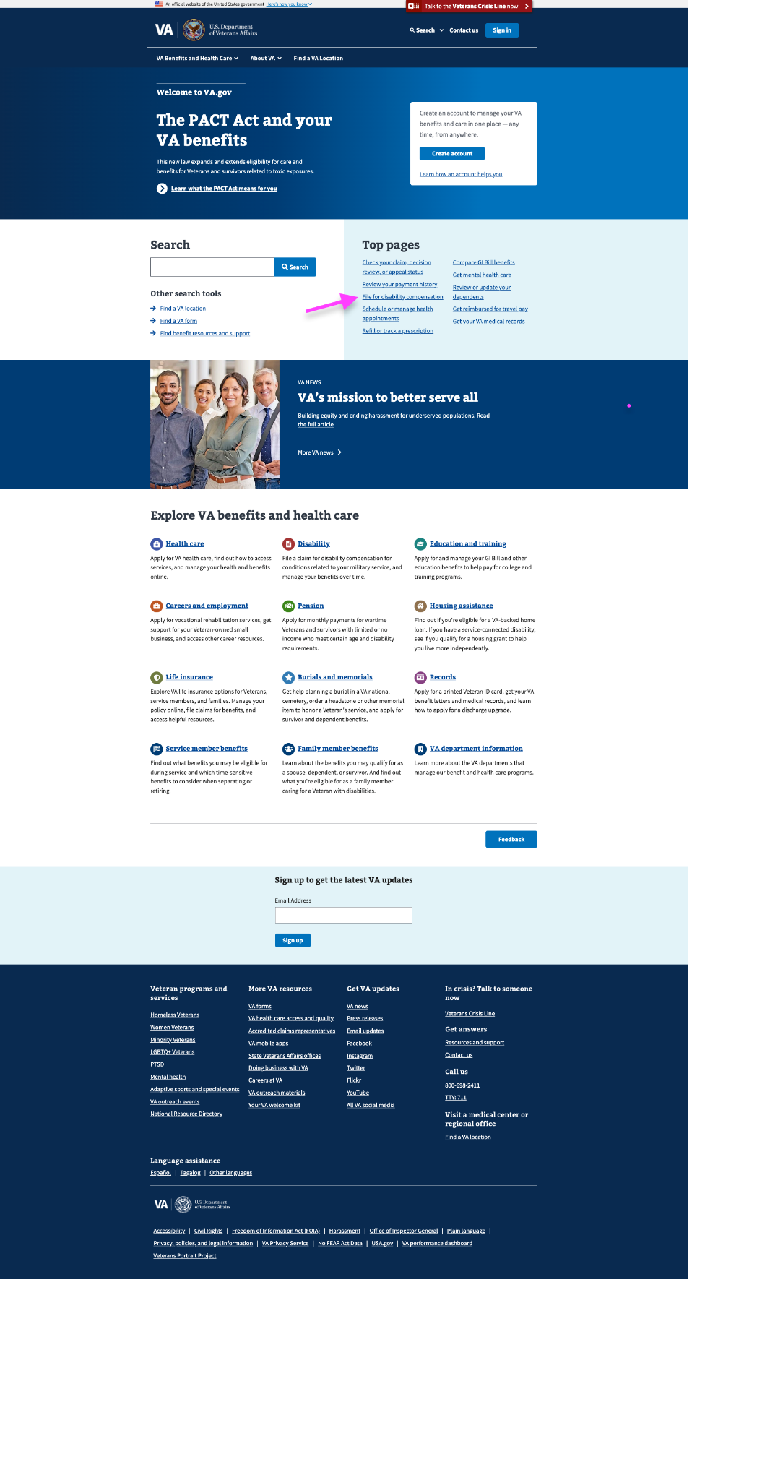

## Is This the Form I Need?

<https://www.va.gov/disability/how-to-file-claim>[/start](https://www.va.gov/disability/how-to-file-claim/)

A Veteran must meet certain criteria to file a claim on VA.gov. The claims wizard tool asks the necessary questions to determine if the Veteran can file a claim on VA.gov. Below are the required criteria:

* Veterans who have separated from their military or uniformed service or are 180 days or less from separation
* Veterans who are filing a claim for a new or secondary disability, or for a condition that has gotten worse  
    
  For Veterans within 90 to 180 days of separation, they will use this same 526ez digital form, but they will be asked different questions. See the 526 Benefits Delivery at Discharge product guide ([https://github.com/department-of-Veterans-affairs/va.gov-team/tree/master/products/disability/526ez/product/526 Benefits Delivery at Discharge - Product Guide](https://github.com/department-of-veterans-affairs/va.gov-team/tree/master/products/disability/526ez/product/526%20Benefits%20Delivery%20at%20Discharge%20-%20Product%20Guide)) for details.

Veterans who want to disagree with a VA decision on a claim will see this message. There are 3 different decision review options. See <https://www.va.gov/resources/choosing-a-decision-review-option/> for details.

After the Veteran has passed through the Claims Wizard, they will be shown the Introduction Page below:

# Intent to File (ITF)

After the Veteran selects the “Start the Disability Compensation Application” link, they will be shown a message about their Intent to File (ITF). An ITF request lets VA know that a Veteran is planning to file a claim. ITF reserves a potential effective date for when a Veteran could start getting benefits while they prepare their disability claim and gather supporting documents.

Depending on the records of the VA, the Veteran might see different information about their ITF.

**Veteran Does Not Have an ITF On File:** If the Veteran does not have an ITF on file, they will create one by clicking the “Start the disability compensation application” link.

|  |  |
| --- | --- |
| Visiting the start link will trigger the creation of an ITF date for the Veteran. | |
|  |  |

After the Veteran visits the link, they will see the below message notifying them that their ITF was submitted.

**Veteran Already Has An ITF Submitted**: This message appears if a Veteran already has an ITF date on record.

**Veteran Has An Expired ITF:** If the Veteran had an ITF that expired, they will see the below message that a new ITF was created.

# Application Functionality

## Part 1: Veteran Details

In this section the Veteran will review their identity and military information to check for accuracy and make corrections as needed.

### Name, Date of birth, Gender

These fields will be pre-populated and can only be viewed in the application. If the Veteran needs them to be changed, they can follow the instructions below the fields.

### 

### Contact Information

Veterans’ contact information is pulled from the Veteran’s profile. Any edits or updates made here will apply only to the 526EZ application.

To update permanent address and email, the Veteran needs to edit this information on their profile page <https://va.gov/profile/contact-information>.

### Homelessness

On this screen, Veterans let us know whether or not they are homeless or at risk of becoming homeless. If they answer “I’m currently homeless” or “I’m at risk of becoming homeless”, we ask the Veteran to provide additional information. If “No”, the Veteran continues to the next screen.

### High Priority Claims

On this page, we ask the Veteran if they are terminally ill to determine whether the claim decision should be expedited.

### 

### Alternate Names

The application will ask if the claimant has served under a different name.

If the Veteran selects “yes,” the page will expand with new fields that must be entered to continue:

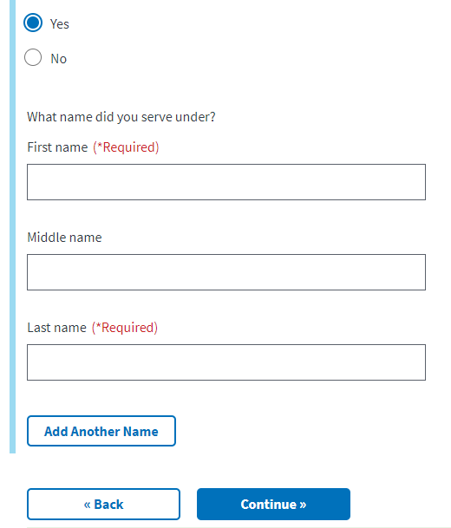

### Military service history

This page will display the military service history the VA has on file for the Veteran. The Veteran can edit this information by clicking the “edit” button and/or add new information by clicking the “Add another service period” button. **Please note, a service end date is required

If a Veteran selects to add another service period, they will see the below screen. The Veteran can enter in the new information and then select continue if that is all the changes they need to make to this section. If they want to add another period of service, they should click the “Add another service period.”

### Separation Pay

Next, the Veteran will be asked if they received separation pay or disability severance pay.

If the Veteran selects no, they will move on to the next page.

If the Veteran selects yes, they received separation pay or disability severance, the page will expand to show the following:

### Retirement Pay and Training Pay

If a Veteran has received retirement pay, they will be required to choose the branch of service that gave them the retirement pay. If not, they will be taken to the next page.

### Training Pay

Next, the Veteran will be asked if they expect to receive active or inactive duty training pay.

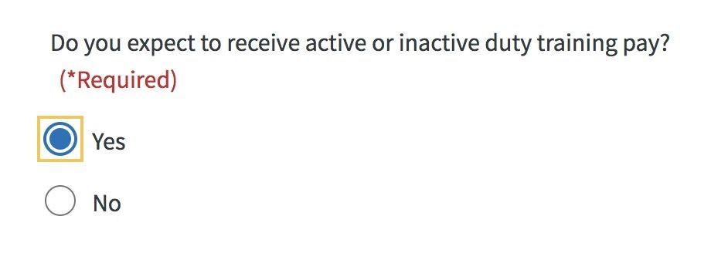

## Part 2: Disabilities

### Claim Type

If the Veteran has any rated disabilities, they must specify the type of claim they would like to file. They can file a claim for a New Condition and/or a Claim for Increase (CFI).

### Rated Disabilities

If filing CFI, the Rated Disabilities screen displays a Veteran’s rated service-connected disabilities. They can choose the condition that they’re filing for an increase because the condition has gotten worse.

If a Veteran has a current rating of 10% for tinnitus, they may see an additional message that says: “You’re already at the maximum rating for tinnitus.” This feature—education about the current rating percentage—is being piloted and only enabled for a subset of Veterans who have a 10% rating for tinnitus.

### New Conditions

The New Conditions screen asks a Veteran to describe or provide information about their new conditions. Short answers are better here. A Veteran will have an opportunity to provide more details on the following screen. As the Veteran types in the text box, a drop down will appear with possible terms. The Veteran can select from these or continue typing what they would like to enter. They can also add multiple conditions to the claim by selecting the “Add Another Condition” button.

For each new condition, Veterans will be asked how their condition is related to their service. Once a service connection type is selected, additional form fields will appear based on the type and the Veteran must answer.

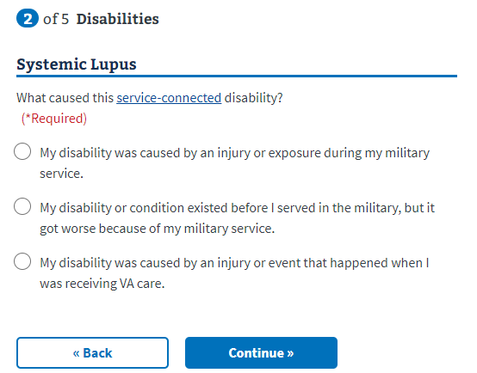

### 

### Prisoner of War

If the Veteran is a Prisoner of War, they’ll be asked for the dates of confinement and if any of their new conditions is related to their POW experience.

### Additional Disability Benefits (Ancillary Wizard)

The Ancillary Forms Wizard asks the Veteran questions about their situation to determine if they’re eligible for additional disability benefits. Based on the Veteran’s answers, the wizard will suggest supplemental forms a Veteran can file with their disability claim (for example, Aid and Attendance benefits, Adaptive Housing benefits, Automobile Allowance, Individual Unemployability).

### Adaptive Benefits

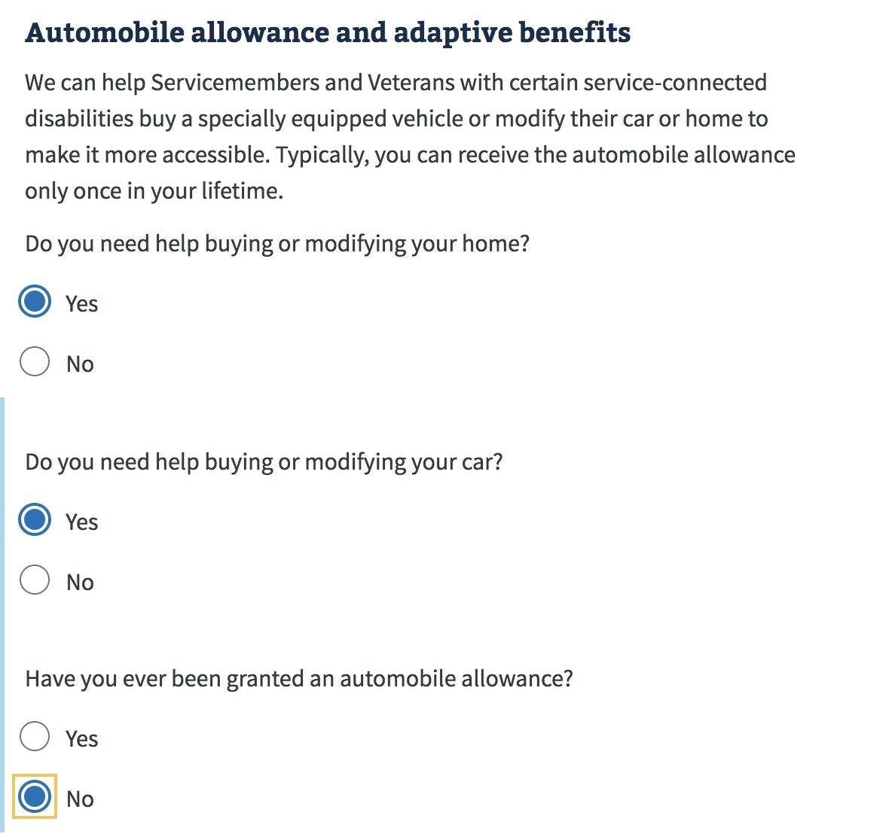

### Aid and Attendance

### Individual Unemployability

### Summary of Additional Benefits

The suggested forms are summarized in a screen for download.

A Summary of Disabilities screen will show new and rated conditions the Veteran is claiming.

## Part 3: Supporting Evidence

In this section, the Veteran can choose whether they would like to include any supporting evidence for their claim.

If the Veteran selects “No,” the following summary screen will display, warning the Veteran that skipping this step may delay processing of their claim.

If the Veteran selects “Yes,” they can select from 1 to 3 options for evidence types.

### VA Medical Records

The Veteran can specify which VA facility they were treated for their condition(s).

### Private Medical Records

The Veteran can specify if they would like to upload medical records or request records from their doctor.

**Upload Private Medical Records**

Follow the provided instructions to upload one or more evidence files. For each file, select a file type.

**Request a Disclosure**

If the Veteran selects “No,” they can select the patient authorization option which will generate Form 21-4142 along with their claim.

The Veteran must fill out information for each medical provider.

### Supporting (Lay) Statements Or Other Evidence

On this page, the Veteran can upload one or more files for supporting (lay) statements or other evidence. For each file, they must select a file type.

**Summary of Evidence**This page provides a summary of any of the 3 supporting evidence types.

**How Claim Exams Work**

On the Exam screen, Veterans can find answers to common questions about a claim exam in the dropdown by selecting the “+” icon.

## Part 4: Additional Information

### Payment Info

Veteran payment information is pre-populated if it exists in the Veteran’s record.

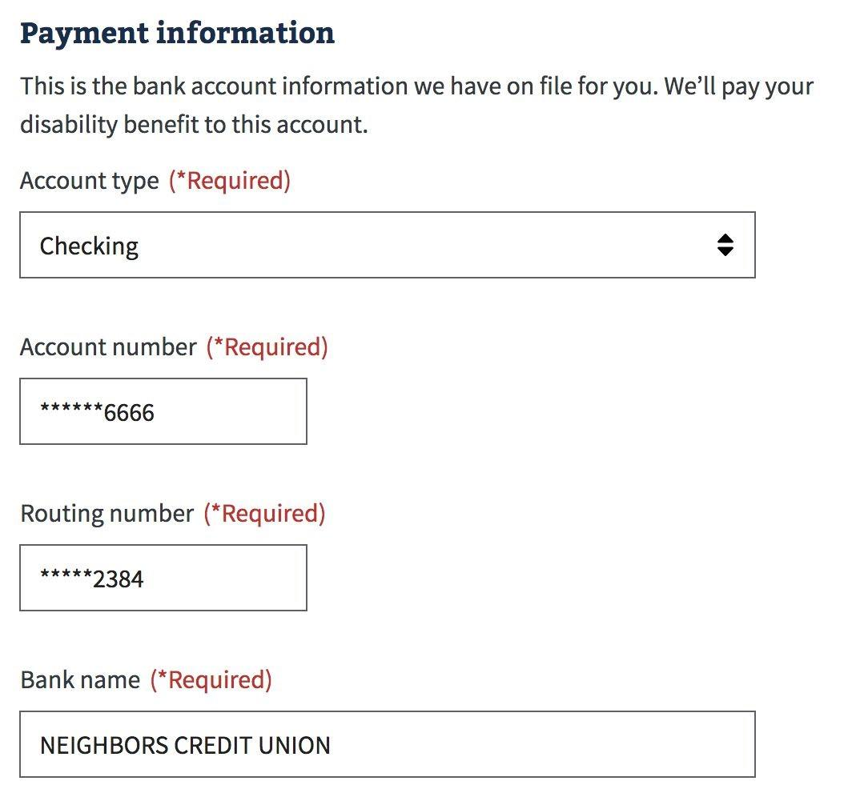

This information can be edited for the 526 application by adding a new account. But the Veteran will receive the below message that the update won’t automatically occur across systems. If the Veteran wants their direct deposit information to be changed now, they should complete that in their profile:

### VA Employee

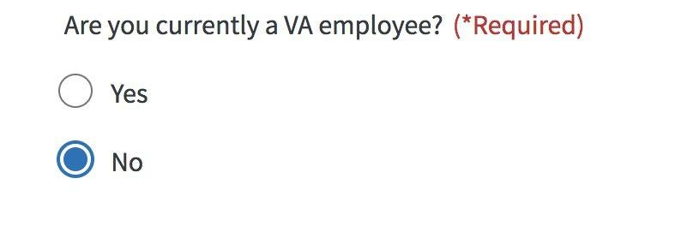

### Retirement Pay Waiver

If a Veteran indicates earlier in the application that they receive retirement pay, we show the following waiver screen.

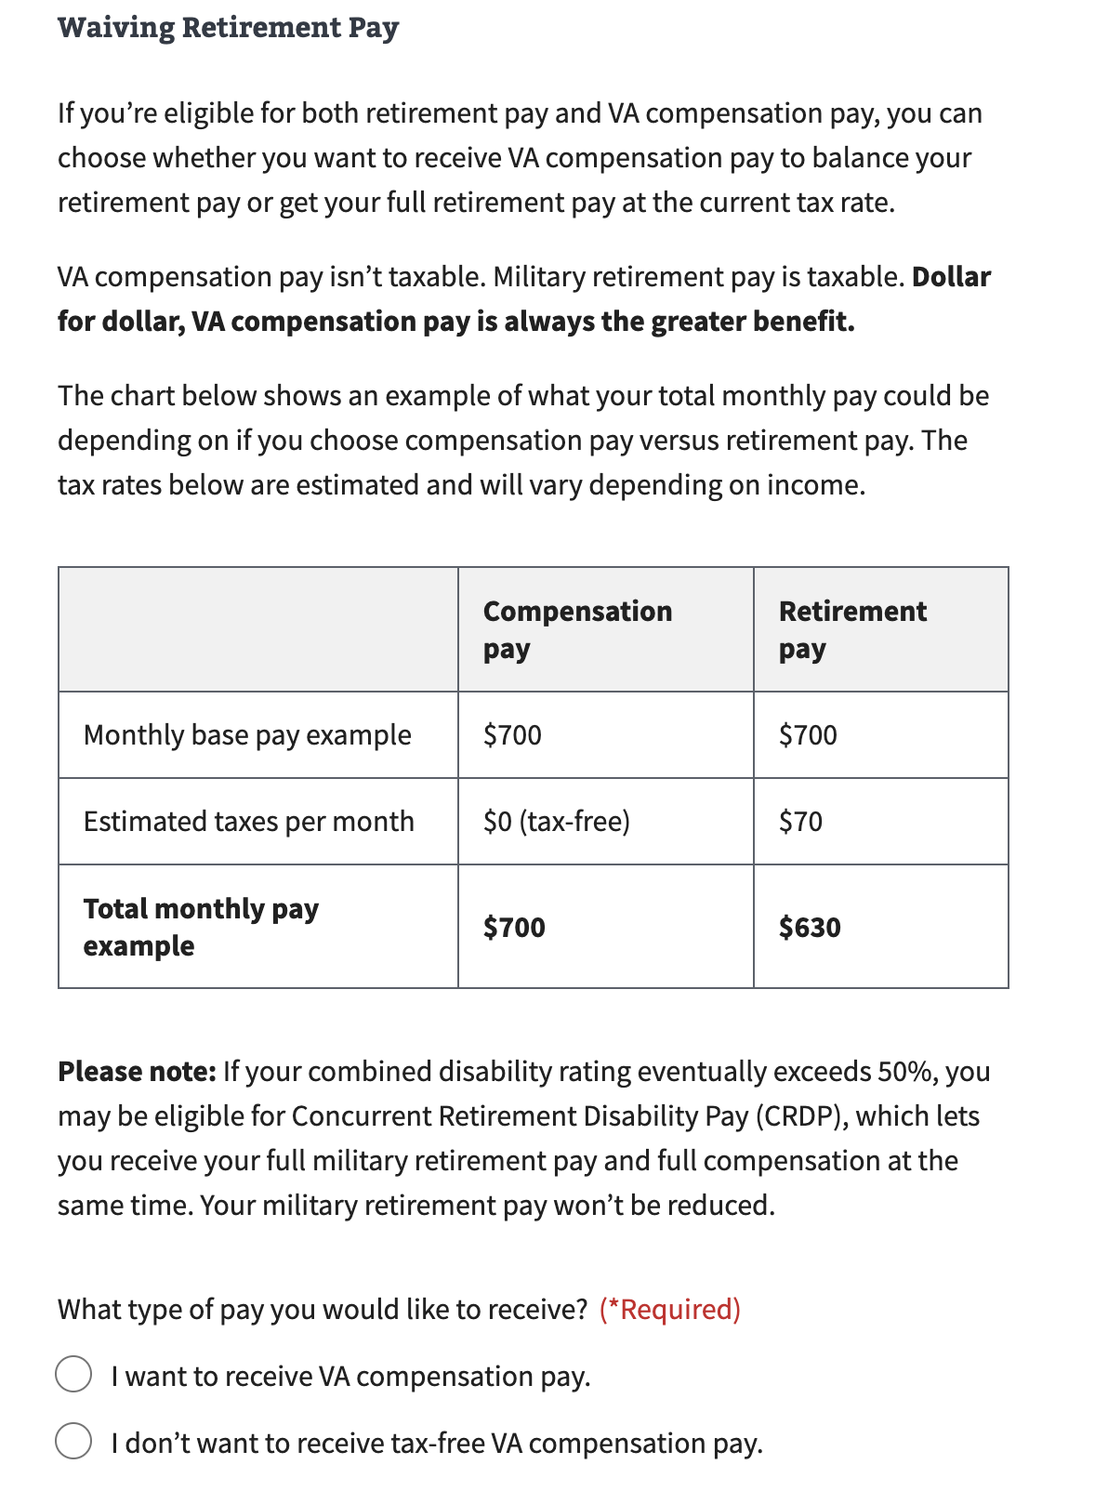

### Training Pay Waiver

If a Veteran indicates earlier in the application that they expect to receive training pay, this page explains to the Veteran they can NOT receive VA compensation for the same days they receive training pay. This form requires the Veteran select whether they want to waive their training pay and instead receive VA compensation or waive VA compensation for the days they receive training pay. This page indicates training pay is typically more than compensation pay.

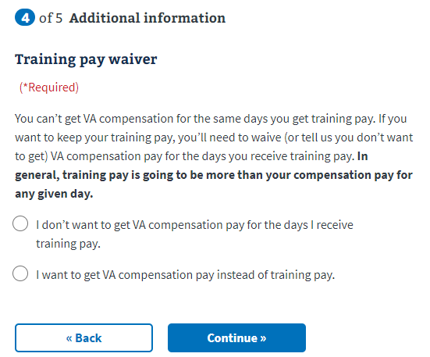

## Part 5: Review Application

Before submitting their application, Veterans can review each section of the form for accuracy, using the “+” toggle buttons to reveal detailed information. To submit the application, acceptance of the privacy policy is required by clicking the provided checkbox.

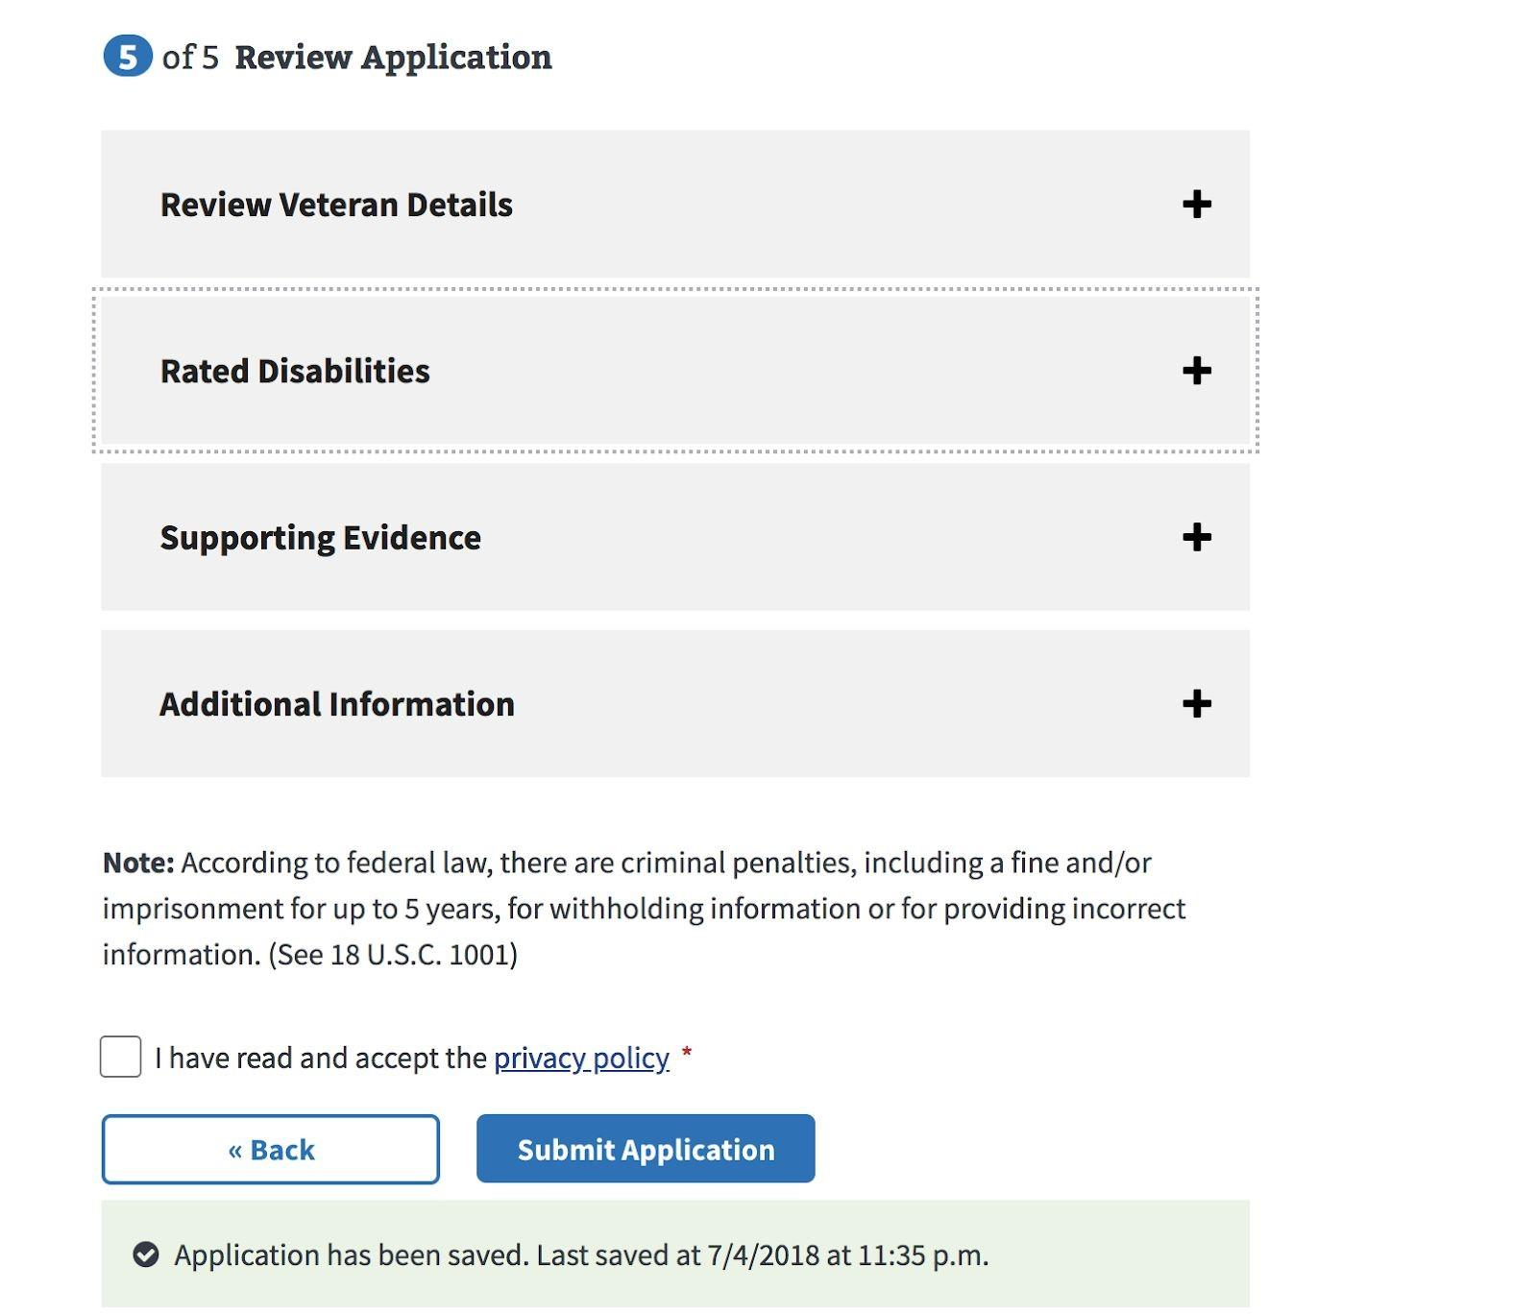

### Successful Submission

Submitted applications will receive a confirmation message that contains a “Claim ID” number that Veterans can use to track their application. A Veteran should be able to review the status of their claim using the Claim Status tool within 24 hours of submitting.

After Submit: A claim is electronically created for the Veteran in the VBMS database for VBA. In addition, a PDF version of Form 21-526EZ form is created and sent to the National Work Queue to be reviewed.

### Success Confirmation

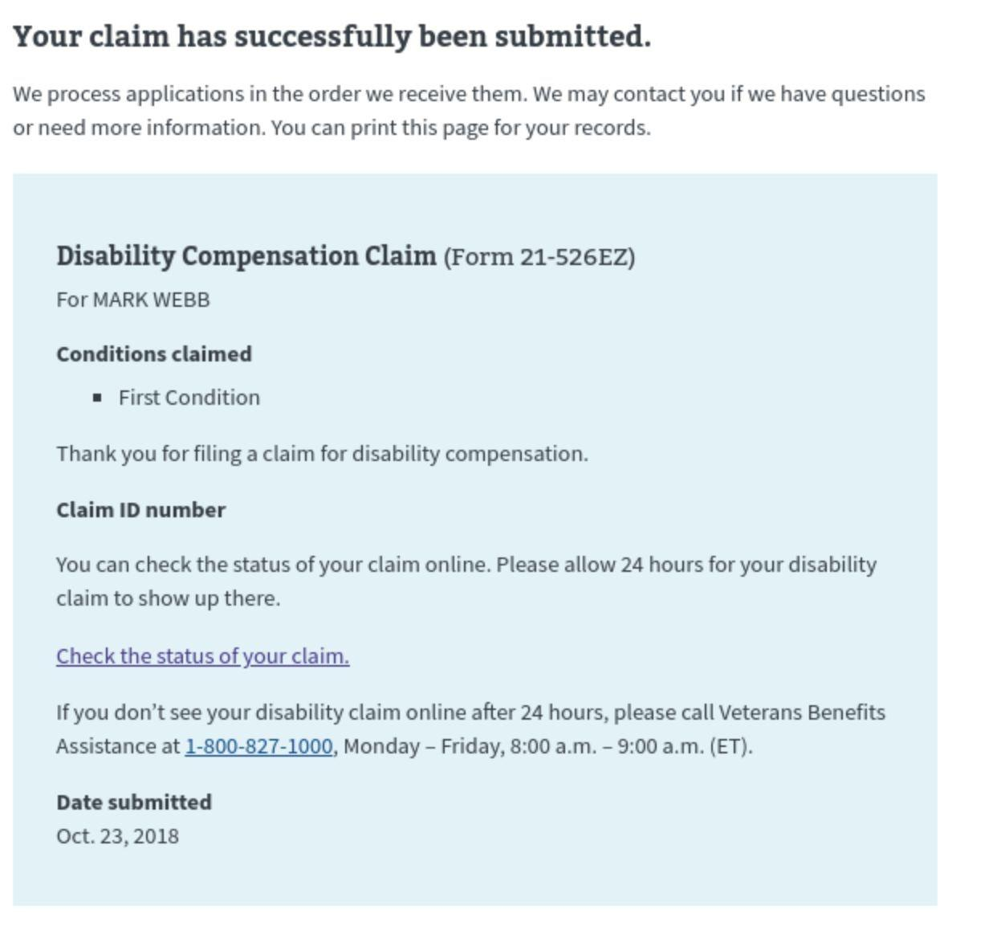

### 

### Check Back Later Confirmation Message

Veterans will see this message when there is a backup of submissions in the queue. The system will retry submitting the application until successful within a 24-hour period.

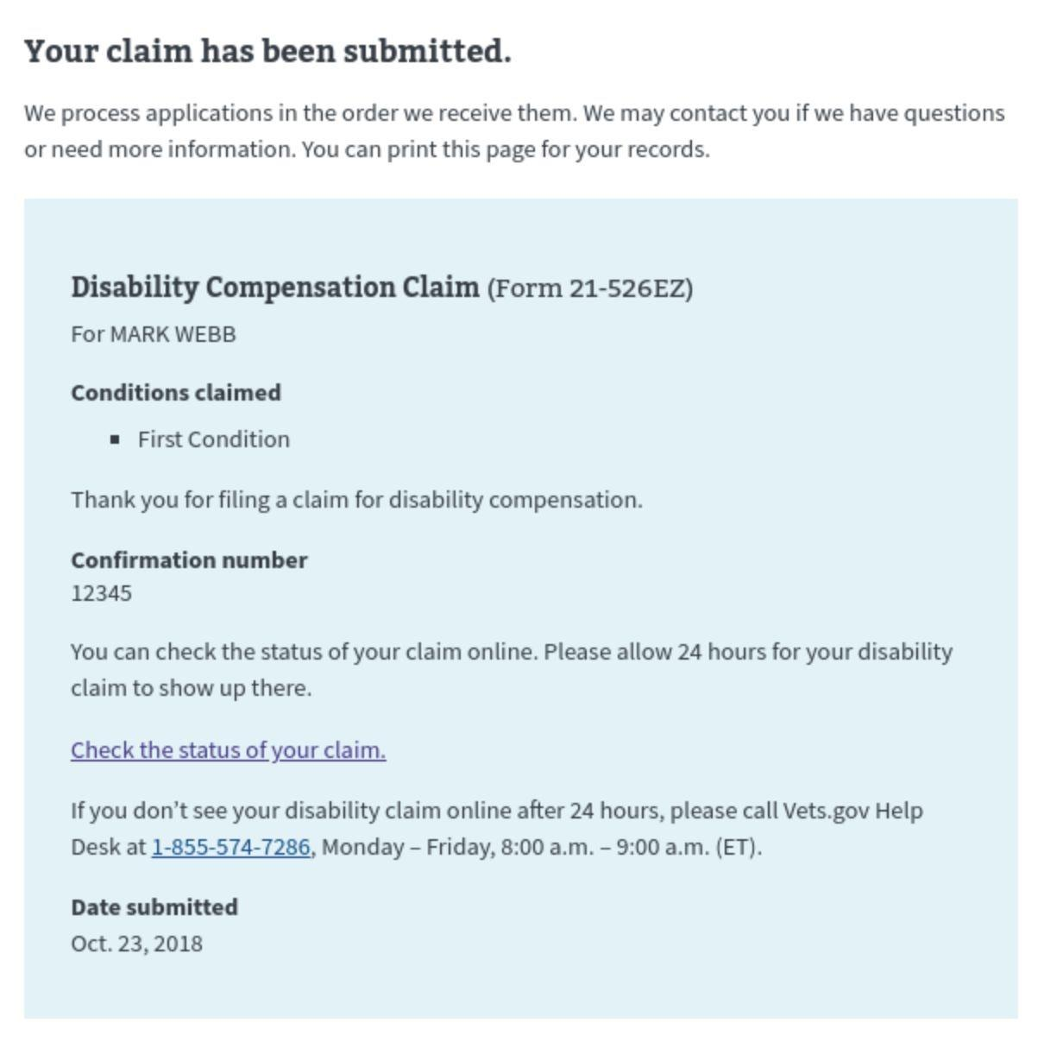

### Error Confirmation

A Veteran might see this error submission message when there is a partner service outage, site maintenance/downtime, or a problem with data quality.

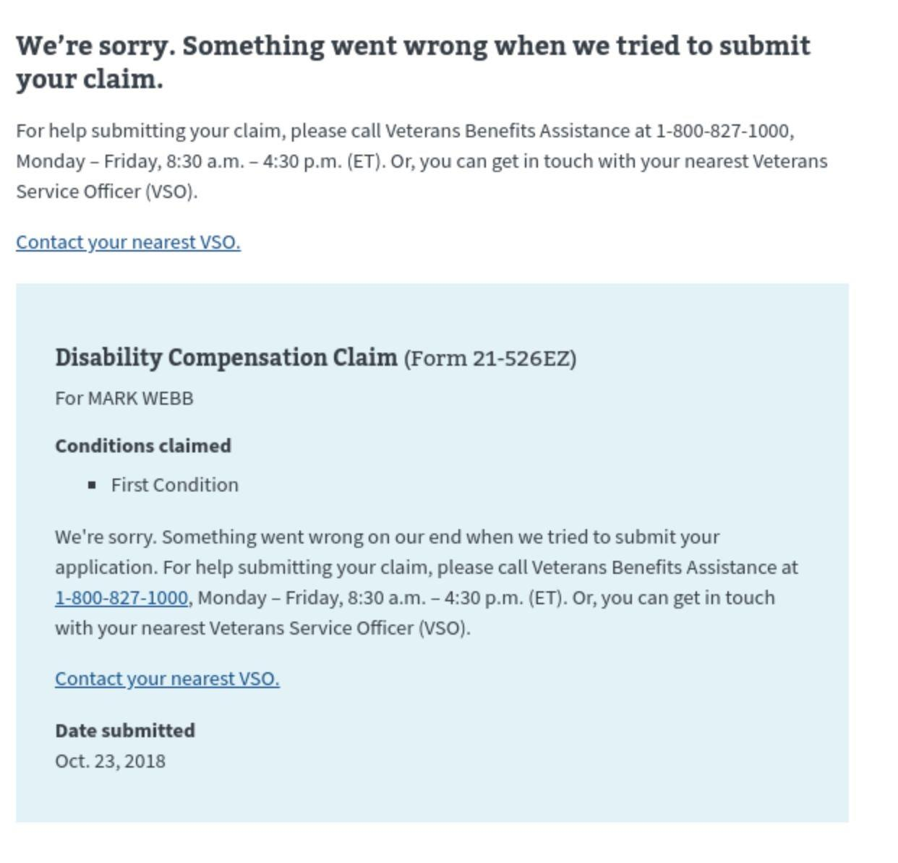

# 

# Major Issues and Error Messages

### Can’t Access Application Because of Missing Account Information

If a Veteran is signed into an LOA1 (not identity verified) account or are signed into an LOA3 (identity verified) account that does not have matching records in MVI, they will see the below error message when trying to access the 526EZ application:

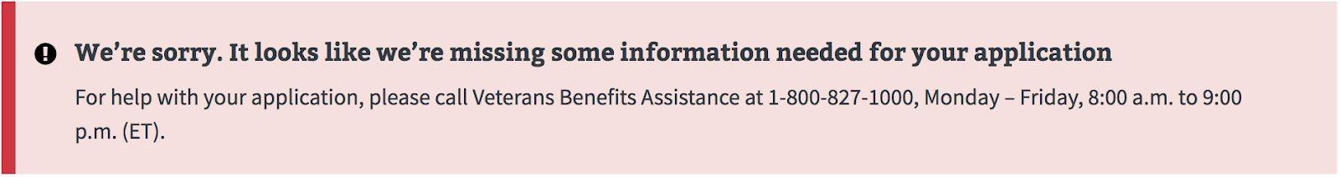

To troubleshoot this issue, the agent should ask the Veteran to go to their account page by selecting the dropdown arrow next to the name or email address in the upper right hand corner and then selecting “Account.”

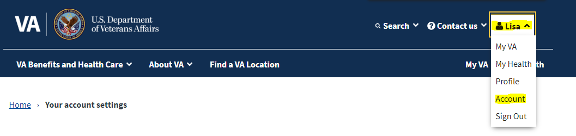

If the Veteran only has an LOA1 account (not identity verified), they will see the below message and will have to verify their identity to complete the application:

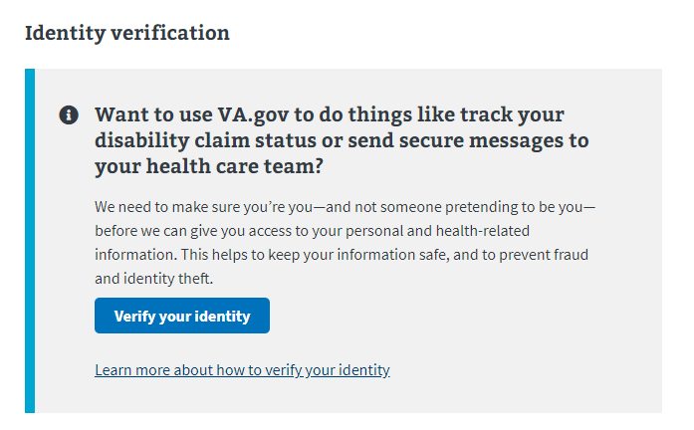

If the Veteran has an LOA3 account (identity verified) but the information does not match the records found in MVI, they will see the below message and will have to follow the instructions to update their records:

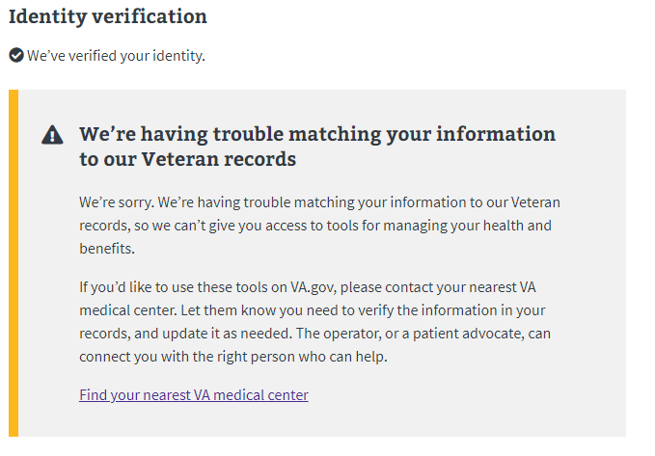

### Intent to File (ITF) Error Messages

Sometimes the system will have trouble creating the ITF. If this happens, explain to the Veteran that there is likely an issue happening with the system and suggest that the Veteran try again at a different time. If the Veteran calls back and says the problem has persisted for several hours/days, this should be escalated to the VA.gov Technical Support team.

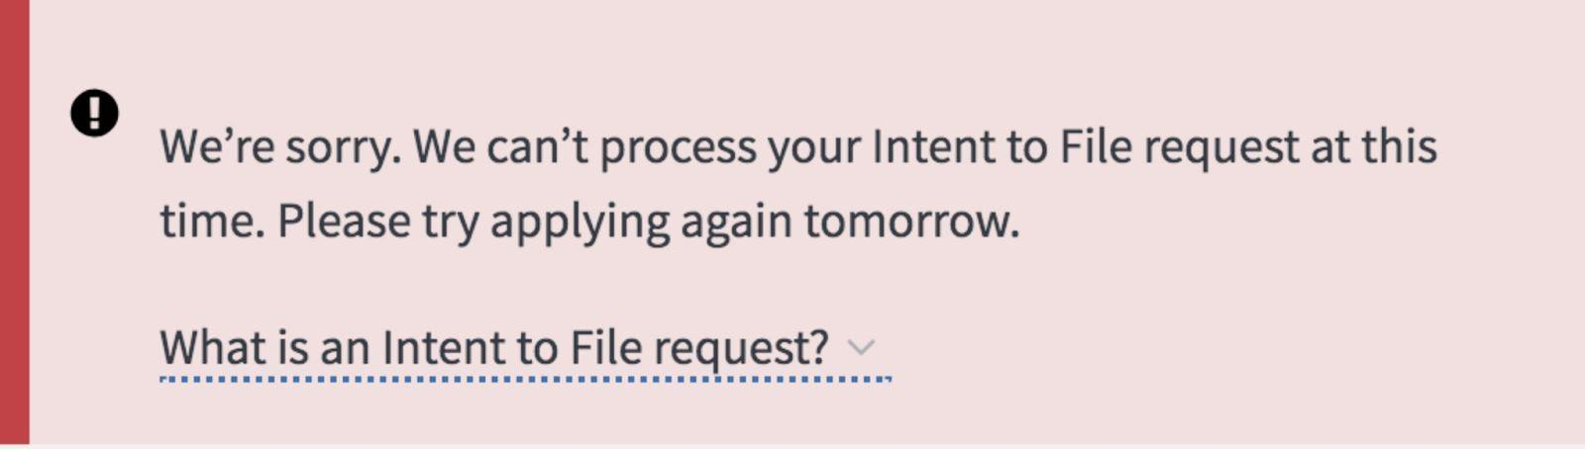

Sometimes the system will have trouble accessing an ITF that already exists. If this happens, explain to the Veteran that there is likely an issue happening with the system and suggest that the Veteran try again at a different time. If the Veteran calls back and says the problem has persisted for several hours/days, this should be escalated to the VA.gov Technical Support team.

Sometimes the system will have trouble renewing an ITF that already exists. If this happens, explain to the Veteran that there is likely an issue happening with the system and suggest that the Veteran try again at a different time. If the Veteran calls back and says the problem has persisted for several hours/days, this should be escalated to the VA.gov Technical Support team.

|  |
| --- |
|  |

### Save in Progress Messages

The following table contains the message types and notifications that would appear for standard errors and failures. Some messages may vary slightly as we develop updated versions of the tool. For more information that can assist the Veteran in these scenarios, see <https://design.va.gov/content-style-guide/error-messages/feedback>.

|  |  |  |  |
| --- | --- | --- | --- |
| Scenario | Title | Description | Location |
| Save in progress data |  | Application has been saved. Last saved on m/dd/yyyy at HH:MM a.m./p.m. | Below affected component |
| Unable to complete an automated task (e.g., save application in progress) | We couldn’t save your form. | We’re sorry. Something went wrong when we tried to save your form. If you’re on a secure and private computer, you can leave this page open and try saving your form again in a few minutes. If you’re on a public computer, you can continue to fill out your form, but it won’t automatically save as you fill it out. | Below affected component |